**Tritek Project Kick off- The essentials. (Team Project Space will be on Basecamp)**

Step 1: Go to Basecamp, identify your project space. Example: Project D

Step 2: Visit the **Message Board** to get information about your team members and project mandate. (Refer to image below).

**Note**: The Message Board is strictly for announcements from the Support staff and should not to used by team members for project conversations.

Step 3: Receive your project mandate on **Message Board** and carry out discussions amongst your team members on **CAMPFIRE** on how to research and tackle the project mandate.

**Note**: **CAMPFIRE** is a space for the team to speak freely about the project and tasks.

Step 4: Choose a Project name and create a project email in the following format: projectname + mmyy @gmail.com. Example: [projectABC092024@gmail.com](mailto:projectABC092024@gmail.com).

Step 5: Visit Tritek Consulting HQ to download the necessary templates for your team. Add those templates to your projects **Docs and Files** for use. Segmenting them into project phases.

Step 6: Prepare Elicitation with the Project Sponsor

Step 7: Invite Sponsor to a meeting

Step 8: Hold meeting, record meeting session, save meeting in project space on Basecamp (Docs and Files) for reference.

Steps 6: Access HLR template, document HLR's

Step 7: Send completed HLR doc to BA/Program office by 4pm every Friday.

**Note:**

1. Use the correct template
2. Send deliverable to ba@tritekconsulting.co.uk

Step 8: Assign a volunteer to present the HLR for the group at the BA Support meetings on Monday's 8pm.

Step 9: Attend BA support meetings every Monday @ 8.00pm to support your team and learn from other teams presenting on the night.

Step 10: Repeat Steps 1-9 for the remaining deliverables stated on the framework.

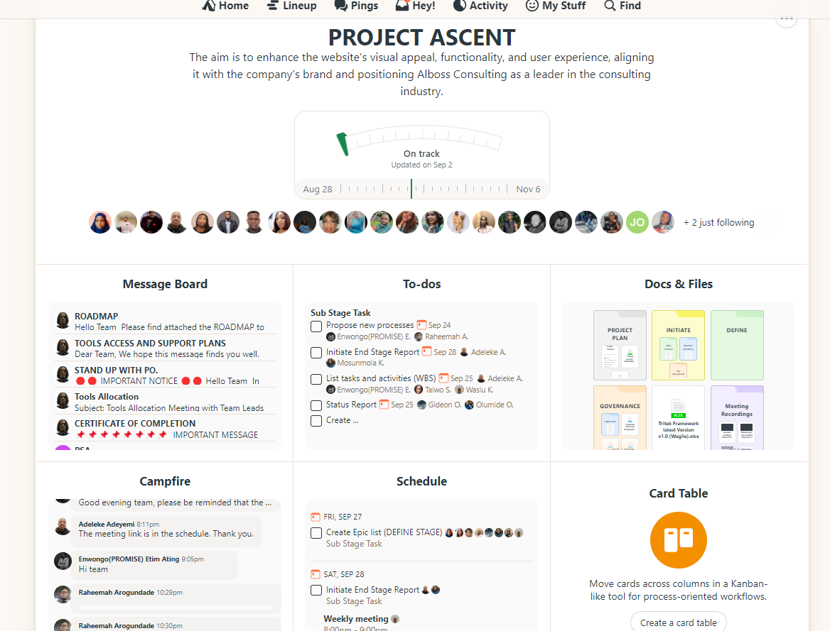

**Drop in Sessions**

The purpose of the drop-in sessions is to enable project teams to present to the PM and BA Support teams any bottlenecks the team may encounter. If in doubt or need BA assistance for example, book a drop-in session. These sessions will be held (Tuesdays and Wednesdays, 6:00pm -8:00pm)

You team will be allocated a time slot.

**Navigating Basecamp**

**To view Tritek Templates and framework**

Step 1: Go to Basecamp Homepage

Step 2: Click on Tritek Consulting HQ

Step 3: Click on Docs & Files

